EXPERIMENT 11 — AUTO_INCREMENT
AIM:
To study the use of the AUTO_INCREMENT property for automatically generating unique customer IDs.
PROCEDURE:
- Create the SHOWROOM_CUSTOMER table with CustomerID as AUTO_INCREMENT.
- Insert customer records without specifying CustomerID.
- Display the records and verify automatically generated IDs.
- Insert a record by manually specifying a customer ID.
- Remove the AUTO_INCREMENT property using ALTER TABLE.
- Display the table structure using DESC.
- Insert another customer record with a manually specified ID.
- Display the final records.
OUT: 1
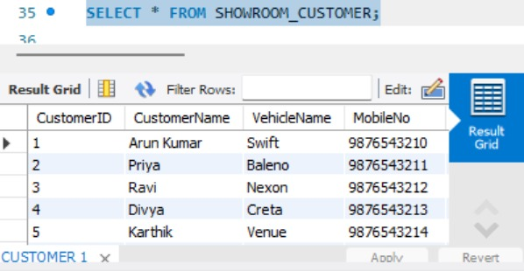
OUT:2
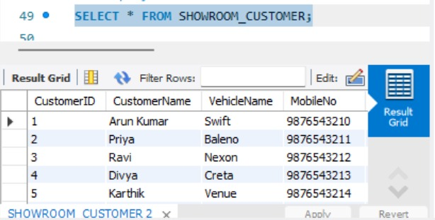
OUT: 3
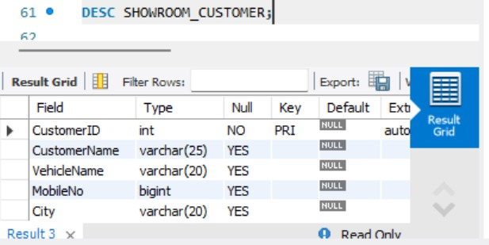
OUT: 4
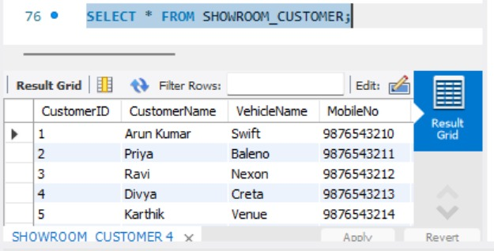
QUERY:
USE AUTOHUB_SHOWROOM;
-- ==========================================
-- 1. CREATE TABLE WITH AUTO_INCREMENT
-- ==========================================
CREATE TABLE SHOWROOM_CUSTOMER (
CustomerID INT AUTO_INCREMENT PRIMARY KEY,
CustomerName VARCHAR(25),
VehicleName VARCHAR(20),
MobileNo BIGINT,
City VARCHAR(20)
);
-- ==========================================
-- 2. POPULATE CUSTOMER ID USING AUTO_INCREMENT
-- ==========================================
INSERT INTO SHOWROOM_CUSTOMER
(CustomerName, VehicleName, MobileNo, City)
VALUES
('Arun Kumar', 'Swift', 9876543210, 'Chennai'),
('Priya', 'Baleno', 9876543211, 'Salem'),
('Ravi', 'Nexon', 9876543212, 'Vellore'),
('Divya', 'Creta', 9876543213, 'Chennai'),
('Karthik', 'Venue', 9876543214, 'Madurai'),
('Meena', 'i20', 9876543215, 'Coimbatore'),
('Surya', 'Verna', 9876543216, 'Tiruvannamalai'),
('Anitha', 'Punch', 9876543217, 'Kanchipuram');
-- Display records
SELECT * FROM SHOWROOM_CUSTOMER;
-- ==========================================
-- 3. MANUALLY POPULATE CUSTOMER ID
-- ==========================================
INSERT INTO SHOWROOM_CUSTOMER
(CustomerID, CustomerName, VehicleName, MobileNo, City)
VALUES
(101, 'Vijay', 'Swift', 9876543220, 'Chennai');
-- Display records
SELECT * FROM SHOWROOM_CUSTOMER;
-- ==========================================
-- 4. DROP AUTO_INCREMENT
-- ==========================================
ALTER TABLE SHOWROOM_CUSTOMER
MODIFY CustomerID INT PRIMARY KEY;
-- Check table structure
DESC SHOWROOM_CUSTOMER;
-- ==========================================
-- 5. MANUALLY INSERT AFTER DROPPING
-- AUTO_INCREMENT
-- ==========================================
INSERT INTO SHOWROOM_CUSTOMER
(CustomerID, CustomerName, VehicleName, MobileNo, City)
VALUES
(102, 'Suresh', 'Creta', 9876543221, 'Salem');
-- Display final records
SELECT * FROM SHOWROOM_CUSTOMER;

RESULT:
Thus, the AUTO_INCREMENT feature was successfully implemented, verified, and removed from the CustomerID column.

